\*Enum

1.Health(HEALTHY,WOUNED,DEAD )

2.Fatiqe(ALERT, TRIED,SLEEPING)

3Nourishment(SATURATED, HUNGRY, STARVING)

GiantMODEL:

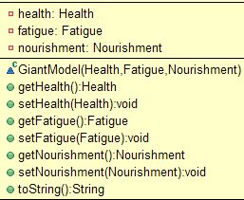

GiantVIEW:

C:\Users\maenul.islam.NTDAC\Pictures\View.JPG

GiantController:

1. GiantModel as a object variable
2. GiantView same as…

